# Bahria University,

## Karachi Campus



COURSE: SEL-401 CLOUD COMPUTING

TERM: SPRING 2024, CLASS: BSE- 6(B)

Submitted By:

Muhammad Shoaib Akhter Qadri_____________79290___

(Name) (Reg. No.)

Submitted To:

Engr. Faisal /Engr. Noor us Sabah

Signed Remarks: Score:_____

INDEX

|  |  |  |  |  |
| --- | --- | --- | --- | --- |
| SNO | DATE | LAB NO | LAB OBJECTIVE | SIGN |
| 01 | 15/02 | 01 | Introduction to Cloud Computing |  |
|  |  |  |  |  |
|  |  |  |  |  |
|  |  |  |  |  |
|  |  |  |  |  |
|  |  |  |  |  |
|  |  |  |  |  |
|  |  |  |  |  |
|  |  |  |  |  |
|  |  |  |  |  |
|  |  |  |  |  |
|  |  |  |  |  |
|  |  |  |  |  |

|  |  |  |  |  |
| --- | --- | --- | --- | --- |
| SNO | DATE | LAB NO | LAB OBJECTIVE | SIGN |
|  |  |  |  |  |
|  |  |  |  |  |
|  |  |  |  |  |
|  |  |  |  |  |
|  |  |  |  |  |
|  |  |  |  |  |
|  |  |  |  |  |
|  |  |  |  |  |
|  |  |  |  |  |
|  |  |  |  |  |
|  |  |  |  |  |
|  |  |  |  |  |
|  |  |  |  |  |
|  |  |  |  |  |

# Bahria University,

## Karachi Campus



LAB EXPERIMENT NO.

**_01_**

LIST OF TASKS

|  |  |
| --- | --- |
| **TASK NO** | **OBJECTIVE** |
| 01 | Setting up First cloud account using Microsoft azure. |
|  |  |
|  |  |
|  |  |
|  |  |
|  |  |
|  |  |
|  |  |
|  |  |
|  |  |
|  |  |

Submitted On:

### Date: _15/02/2024_

[Lab no. 01] [CLOUD COMPUTING LAB]

[Introduction to Cloud Computing]

### Task No. 01:

**“**Setting up First cloud account using Microsoft azure.**”**

### Solution:

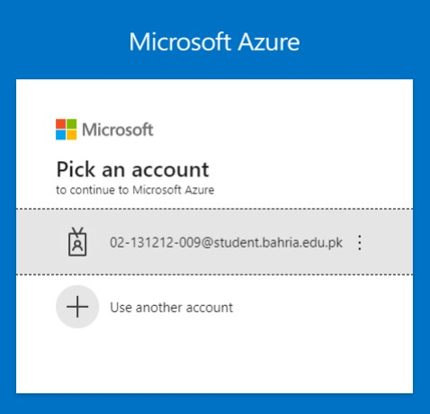

*MUHAMMAD SHOAIB AKHTER QADRI 02-131212-009*

[Lab no. 01] [CLOUD COMPUTING]

[Introduction to CLOUD COMPUTING]

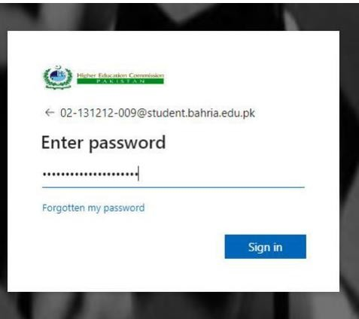

### Output:

MUHAMMAD SHOAIB AKHTER QADRI 02-131212-009

[Lab no. 01] [CLOUD COMPUTING]

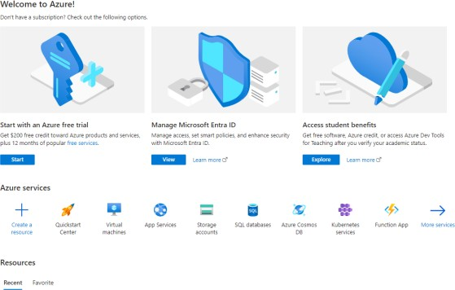[Introduction to CLOUD COMPUTING]

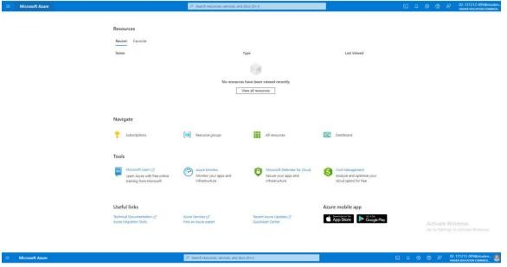

MUHAMMAD SHOAIB AKHTER QADRI 02-131212-009

[Lab no. 01] [CLOUD COMPUTING]

[Introduction to CLOUD COMPUTING]

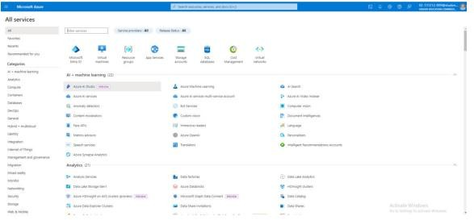

MUHAMMAD SHOAIB AKHTER QADRI 02-131212-009